Experiment 6



American International University- Bangladesh

Department of Electrical and Electronic Engineering

**EEE3102:Digital Logic & Circuits Laboratory**

**Title:** Study of Different Flip-Flops.

# Introduction:

The basic building blocks of combinational logic circuits are gates. In particular, AND, OR, and NOT gates (however, there are also, XOR, NAND, NOR, XNOR gates too).

The basic building blocks of sequential logic circuits are flip flops. Flip flops are devices that use a clock. Each flip flop can store one bit. There are different types of flip-flop. D flip-flop, T flip-flop, J-K flip-flop etc.

# Theory and Methodology:

Basically, a flip flop has two/three inputs. One input is a control input. For a D flip flop, the control input is labeled D. For a T flip flop, the control input is labelled T. For J-K flipflop the control inputs are J and K.The other input is the clock.

The clock input is usually drawn with a triangular input. These flip-flops are *positive edge- triggered flip flops*. This means that the flip flops can only change output values when the clock is at a positive edge. There are also negative edge triggered flip flops, which change on a negative edge. In this theory section, we consider only positive edge-triggered flip flops.

When the clock is not at a positive edge, then the output value is held. That is, it does not change.

A flip flop also has two outputs, **Q** and **Q'**. The output is really the bit that's stored. Thus, the flip flop is always outputting the one bit of information.

But one might wonder "Doesn't it have two bits of information? **Q** and **Q'**?” If we have two bits, we have four possible values. However, **Q'** is the negation of **Q** which means you only have two possible outputs: **Q = 0, Q' = 1** or **Q = 1, Q' = 0**. Since the second output is always negated from the first, you don't get any additional storage. But what is the necessity of the negated output? Actually, the design of flip-flop gives **Q'**basically for free, so that's why flip flops have both the regular output and the negated output.

# D Flip-Flop:

In a positive edge triggered D flip-flop, the output **Q** samples the input **D** and becomes **Q = D** only at the positive edge of the clock and it does not change during the whole clock cycle even if the input changes.

Sometimes flip flops often have two additional inputs called *clear*and*preset*. Conventionally they are drawn at the top and bottom of the flip flop respectively. ‘Preset’ and ‘Clear’ can be either active low or active high. If the preset is active, the output will be 1 no matter what are the conditions of D or clock. But ‘clear’ is of two types. Asynchronous clear and synchronous clear.If the asynchronous clear is activated, it causes **Q** to be automatically set to 0. It does

this, even if the clock has not reached a positive edge. That is, it sets Q to zero as fast as it can. The asynchronous clear is often used to reset flip flops to some initial value. But for synchronous clear, **Q** will be 0 if the clear is active when the clock is in a positive edge.

There are different ways to design a D flip-flop. In this lab sheet, only one way is shown. Students will be familiar about other ways in their theory class.

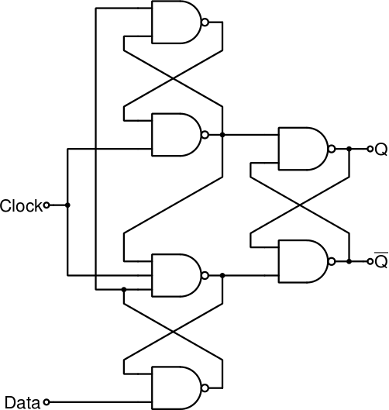

**Figure1:** Logic circuit a positive edge triggered D flip-flop without preset and clear capability.

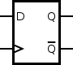

**Figure 2:**Graphical Symbol of a positive edge triggered D flip-flop without preset and clear capability.

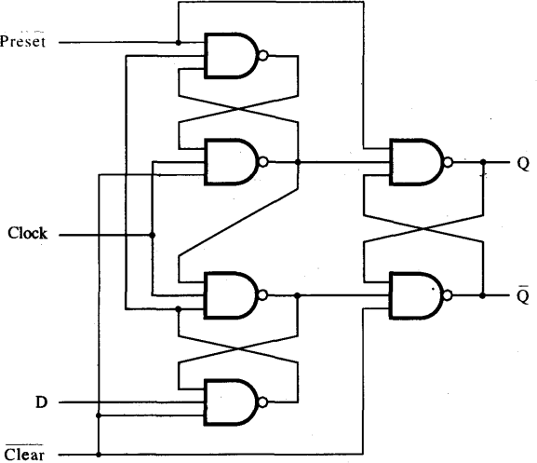

**Figure3:**Logic circuit a positive edge triggered D flip-flop with preset (active low) and asynchronous clear (active low) capability.

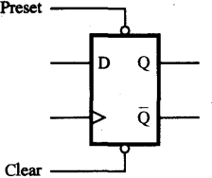

**Figure4:** Graphical symbol of a positive edge triggered D flip-flop with preset (active low) and asynchronous clear (active low) capability.

# J-K Flip Flop:

In a J-K flip-flop, there are two control input labeled as J and K and a clock input. It has two outputs Q and Q’ as usual. In a positive edge triggered J-K flip-flop, output only changes at the positive edge of the clock depending on the values of J and K. If J=1 and K=0, Q is set to

1. If J = 0, K=1 then Q is set to 0. If J = 0 and K = 0 then Q remains unchanged. If J = 1 and K = 1 then Q changes from its former value, which we can say the output toggles.

We can show the characteristics of a J-K in a table given below.

|  |  |  |
| --- | --- | --- |
| J | K | Q(t+1) |
| 0 | 0 | Q(t) |
| 0 | 1 | 0 |
| 1 | 0 | 1 |
| 1 | 1 | ~ Q(t) |

J-K flip-flop can be designed easily using D flip-flops.

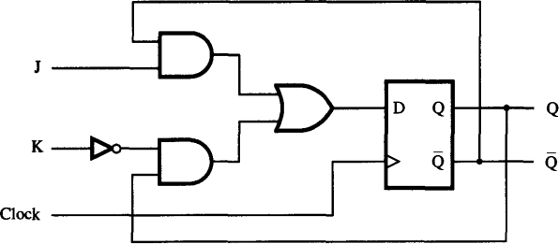

**Figure 5:** J-K flip-flop using D flip-flop

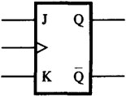

**Figure 6:** Graphical Symbol of J-K flip-flop.

# T Flip-Flop:

A T flip-flop has a control input labeled as T and a clock. The characteristic of a T flip-flop is such that the output toggles at the positive edge of the clock if T is 1. But if T is 0, the output remains unchanged even at the positive edge of the clock.

A T flip-flop can be designed easily by making J and K short of a J-K flip flop.

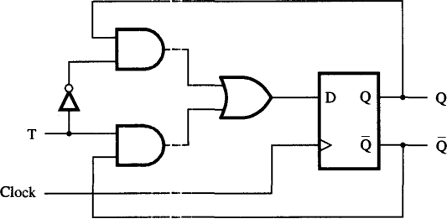

**Figure 7:** J-K flip-flop using D flip-flop

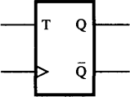

**Figure 8:** Graphical Symbol of T flip-flop.

There are built-in ICs for D flip-flop and J-K flip-flop. IC-7474 contains 2 D flip-flops and IC-7476 contains 2 J-K flip-flops. The pin configuration of IC-7474 and IC 7476 are given below.

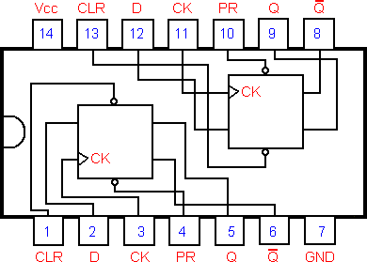

**Figure 9:** IC-7474

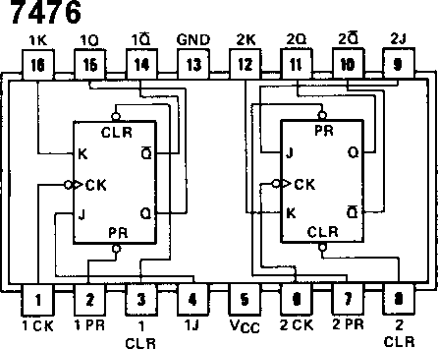

**Figure10:** IC-7476

# Pre Lab Homework:

1. Learn the differences between a combinational logic and sequential logic.
2. Learn about different terminologies of clock such as positive edge, negative edge.
3. Learn the difference between level triggered and edge triggered devices.

# Apparatus:

IC : 7404 (NOT Gate) 1[pcs] 7408 (AND Gate), 2[pcs] 7432 (OR Gate) 1[pcs]

7400 (NAND Gate) 6[pcs] 7474 (D flip-flop) 1[pcs] 7476 (J-K flip-flop) 1[pcs]

# Precaution:

Never make the ‘Preset’ and ‘Clear’ both active at a time. Otherwise you may get erroneous result.

# Experimental Procedure:

Implement the circuits shown in fugure1, figure3, figure5 and figure7 on the trainer board and observe the input-output characteristics. Use pulse switch as clock. Generate timing diagrams from the implemented circuits.

# Simulation and Measurement:

Timing Diagram of a positive edge trigged D flip-flop without ‘Preset’ and ‘Clear’ capability:

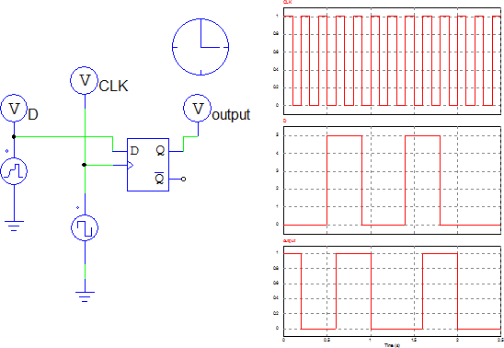

**Figure11:** Timing Diagram of a positive edge triggered D Flip-Flop without preset and clear capability. Output only samples the input when the clock has a positive edge and remains unchanged for the next positive edge.

Timing Diagram of a positive edge trigged J-K flip-flop:

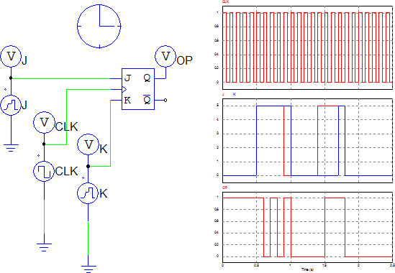

**Figure12:** Timing Diagram of J-K Flip-Flop Timing Diagram of a positive edge trigged T flip-flop:

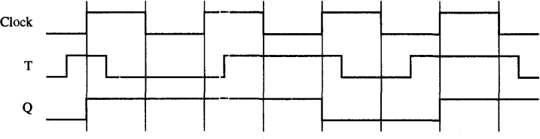

**Figure13:** Timing Diagram of T-flip-flop

# Discussion and Conclusion:

After performing this experiment students will be familiar with the design of positive edge triggered D flip-flop with and without ‘Preset’ and ‘Clear’ capabilities, J-K flip-flop and T- flip-flop. After the experiment, their job is to design negative edge triggered flip-flops and draw the timing diagrams for them. They will also design and draw timing diagram for a D flip-flop having active high ‘Preset’ and ‘Clear’ pin.

# Reference:

1. “Fundamentals of Digital Logic with verilog design” by – Brown &Vranesic
2. [www.wikipedia.org](http://www.wikipedia.org/)
3. <http://www.cs.umd.edu/class/spring2003/cmsc311/Notes/Seq/flip.html>